DIRB TOOL – COMPREHENSIVE TECHNICAL DOCUMENTATION
A Web Content Discovery Tool for Ethical Hacking & Penetration Testing

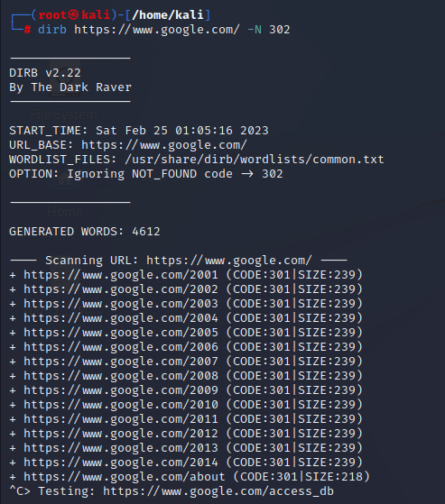
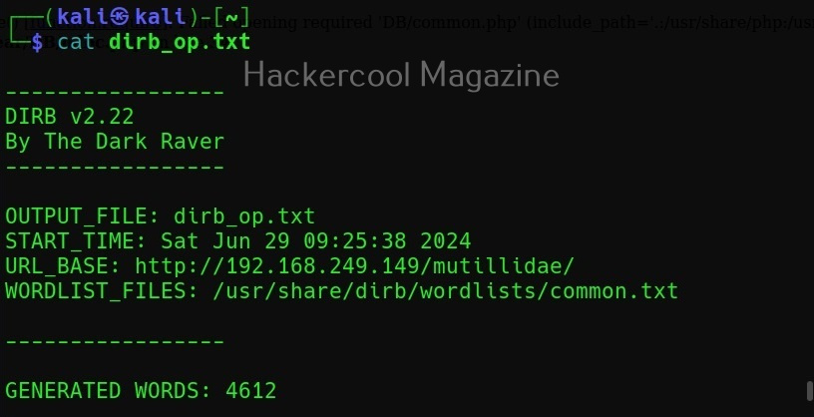
4

ABSTRACT
Web applications form a major attack surface in modern cyber environments. Many vulnerabilities originate not from visible pages but from hidden directories, files, and backup resources unintentionally exposed on web servers. This document presents a comprehensive technical study of DIRB, a classic web content discovery and directory brute-forcing tool used in penetration testing. The report explains the theoretical background, internal working mechanism, command usage, practical case studies, advantages, limitations, and defensive considerations. The objective of this documentation is to provide an academic and practical understanding of DIRB suitable for cybersecurity coursework, lab records, interviews, and professional penetration testing engagements.

1. INTRODUCTION
Web servers often host far more content than what is linked through the visible user interface. Developers may leave behind directories for testing, backups, administration, or deprecated applications. These hidden resources can expose sensitive information such as configuration files, credentials, source code, or administrative panels.
Web directory enumeration is the process of discovering these hidden files and folders by systematically requesting common directory and file names. Attackers frequently use this technique to locate vulnerable entry points in web applications.
DIRB is one of the earliest and most widely used tools for web directory brute forcing. Despite its simplicity, it remains highly effective and is commonly used for learning, labs, and real-world assessments.

2. OBJECTIVE OF THE STUDY
The objectives of this documentation are:
- To understand web directory and file enumeration
- To study the working mechanism of DIRB
- To analyze DIRB command usage and options
- To demonstrate real-world usage through a practical case study
- To evaluate strengths, limitations, and security implications
- To provide exam-ready and submission-ready content

3. BACKGROUND: WEB CONTENT DISCOVERY IN CYBER SECURITY
Web content discovery is part of the Scanning & Enumeration phase of penetration testing. It focuses on identifying:
- Hidden directories and files
- Backup and configuration files
- Administrative panels
- Old or deprecated applications
Because HTTP responses can reveal whether a resource exists, brute-force enumeration becomes an effective attack technique if proper access controls are not enforced.
DIRB uses this principle to enumerate content efficiently.

4. OVERVIEW OF DIRB TOOL
DIRB is an open-source web content scanner written in C and included by default in Kali Linux. It performs dictionary-based brute forcing against web servers to discover existing directories and files.
DIRB uses:
- HTTP GET requests
- Wordlists containing common directory and file names
DIRB does not exploit vulnerabilities directly; instead, it identifies potentially sensitive resources that can later be tested for vulnerabilities.

5. ARCHITECTURE AND WORKING MECHANISM

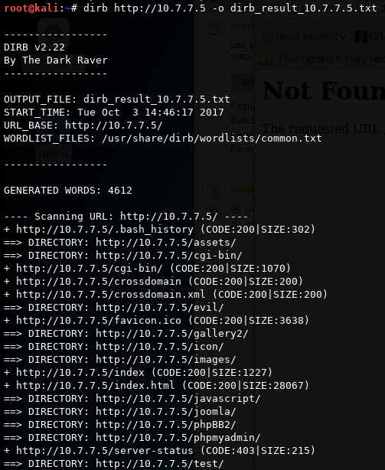
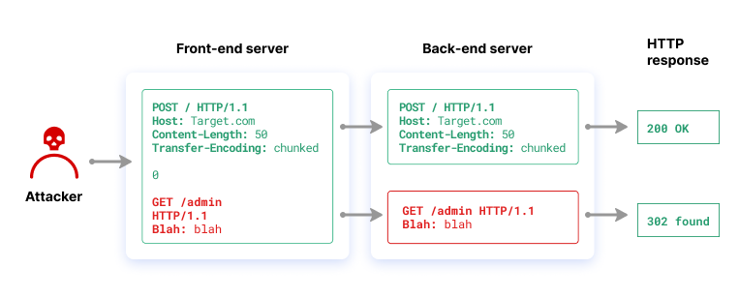
DIRB follows a straightforward brute-force workflow:
- Target URL Input
The user provides the base URL of the web application.
- Wordlist Loading
DIRB loads a predefined or custom wordlist.
- HTTP Request Generation
Each word is appended to the URL and requested via HTTP.
- Response Analysis
HTTP status codes are analyzed to determine valid resources.
- Result Reporting
Discovered directories and files are displayed.
This systematic approach enables thorough web enumeration.

6. INSTALLATION AND ENVIRONMENT
DIRB is pre-installed in Kali Linux.
To verify installation:
dirb
DIRB requires only a network connection and does not require special privileges.

7. COMMAND USAGE AND ANALYSIS
7.1 Basic Directory Enumeration
dirb http://example.com
Uses the default wordlist to discover directories and files.

7.2 Using a Custom Wordlist
dirb http://example.com custom_wordlist.txt
Useful when targeting applications with predictable naming conventions.

7.3 Scan HTTPS Websites
dirb https://example.com
Supports both HTTP and HTTPS.

7.4 Save Output to File
dirb http://example.com -o dirb_results.txt
Stores enumeration results for reporting.

7.5 Ignore Specific HTTP Status Codes
dirb http://example.com -N 403
Filters out forbidden responses to reduce noise.

8. PRACTICAL CASE STUDY
Scenario
A penetration tester assesses a web application hosted on an internal server.
Execution
dirb http://192.168.146.131
Observations
- Discovered /admin/ directory
- Found /backup/ containing old files
- Identified /test/ environment
Impact Analysis
These directories exposed sensitive areas of the application, enabling further attacks such as authentication bypass, file disclosure, and configuration leakage.

9. ADVANTAGES OF DIRB
- Simple and easy to use
- Effective for basic web enumeration
- Lightweight and fast
- Ideal for learning and labs
- Pre-installed in Kali Linux

10. LIMITATIONS OF DIRB
- Slower compared to modern tools like Gobuster
- Limited threading options
- No recursive scanning by default
- Basic response filtering

11. DIRB VS OTHER WEB ENUMERATION TOOLS
Tool | Technique | Strength
DIRB | Dictionary brute force | Simplicity
Gobuster | Multithreaded brute force | Speed
Feroxbuster | Recursive scanning | Depth
WFuzz | Fuzzing-based | Flexibility
DIRB is best suited for basic and educational web enumeration.

12. SECURITY AND DEFENSIVE CONSIDERATIONS
Organizations can defend against directory brute forcing by:
- Disabling directory listing
- Using proper access controls
- Implementing rate limiting
- Deploying web application firewalls

13. LEGAL AND ETHICAL CONSIDERATIONS
DIRB must only be used on web applications where explicit authorization has been granted. Unauthorized directory brute forcing may be considered illegal reconnaissance.

14. CONCLUSION
DIRB is a foundational web enumeration tool that demonstrates how hidden web content can be discovered through systematic brute forcing. While simple in design, it remains highly effective for identifying sensitive directories and files. Understanding DIRB provides cybersecurity students and professionals with essential knowledge of web reconnaissance techniques.

15. REFERENCES
- Kali Linux Documentation
- OWASP Web Security Testing Guide
- HTTP Protocol Specification

